JSON in Web Development

🌟 What is JSON in Web Development?
# Source: AI Source: Provided by: [Data Path: Persons Table -> ID Column: 1, Name_En Column: Motasem Essam] -> From: [ChatGPT] on [5/31/2026]
In web development, JSON is used to transfer data between the frontend (browser) and backend (server) so websites and applications can display dynamic content.

🔗 How JSON is Used on Websites
# Source: AI Source: Provided by: [Data Path: Persons Table -> ID Column: 1, Name_En Column: Motasem Essam] -> From: [ChatGPT] on [5/31/2026]
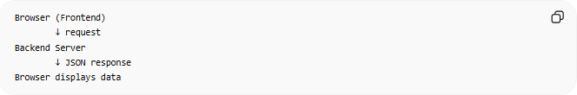
Browser (Frontend)
↓ request
Backend Server
↓ JSON response
Browser displays data

🔢 Main Uses of JSON in Web Development

🖥️ 1. Frontend Uses JSON
# Source: AI Source: Provided by: [Data Path: Persons Table -> ID Column: 1, Name_En Column: Motasem Essam] -> From: [ChatGPT] on [5/31/2026]
Frontend (HTML, CSS, JavaScript) uses JSON to:
- Show user data
- Display posts, products, or profiles
- Update page content dynamically

⚙️ 2. Backend Sends JSON
# Source: AI Source: Provided by: [Data Path: Persons Table -> ID Column: 1, Name_En Column: Motasem Essam] -> From: [ChatGPT] on [5/31/2026]
Backend (Node.js, PHP, Python, etc.) sends data in JSON format.
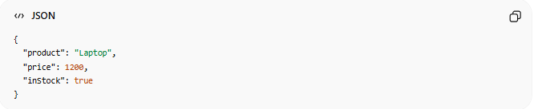
Example response:
{
"product": "Laptop",
"price": 1200,
"inStock": true
}

🌐 3. Fetching JSON in JavaScript
# Source: AI Source: Provided by: [Data Path: Persons Table -> ID Column: 1, Name_En Column: Motasem Essam] -> From: [ChatGPT] on [5/31/2026]
Modern websites use fetch() to get JSON:
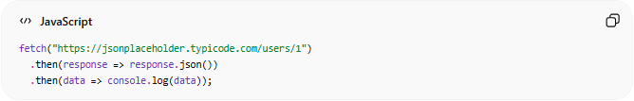
fetch("https://jsonplaceholder.typicode.com/users/1")
.then(response => response.json())
.then(data => console.log(data));

📡 4. JSON + API Communication
# Source: AI Source: Provided by: [Data Path: Persons Table -> ID Column: 1, Name_En Column: Motasem Essam] -> From: [ChatGPT] on [5/31/2026]
Web apps use APIs to get JSON data.
Example API:
JSONPlaceholder Users

🧩 5. Updating Web Pages with JSON
# Source: AI Source: Provided by: [Data Path: Persons Table -> ID Column: 1, Name_En Column: Motasem Essam] -> From: [ChatGPT] on [5/31/2026]
Example:
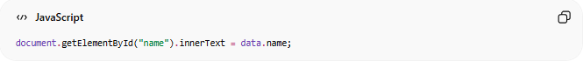
document.getElementById("name").innerText = data.name;
👉 JSON data fills website content dynamically.

📱 6. JSON in Modern Web Apps
# Source: AI Source: Provided by: [Data Path: Persons Table -> ID Column: 1, Name_En Column: Motasem Essam] -> From: [ChatGPT] on [5/31/2026]
Used in:
- React
- Angular
- Vue
- Next.js
Example:
- Load users from API
- Display products
- Show dashboards

🧠 Simple Idea
# Source: AI Source: Provided by: [Data Path: Persons Table -> ID Column: 1, Name_En Column: Motasem Essam] -> From: [ChatGPT] on [5/31/2026]
Think of JSON in web development like:
📦 Food delivery system
- Website = customer
- Server = restaurant
- JSON = food package
- API = delivery system

⚠️ Why JSON is important in Web Development
# Source: AI Source: Provided by: [Data Path: Persons Table -> ID Column: 1, Name_En Column: Motasem Essam] -> From: [ChatGPT] on [5/31/2026]
- Makes websites dynamic
- Connects frontend and backend
- Enables real-time data updates
- Works with all modern frameworks

🧭Summary
# Source: AI Source: Provided by: [Data Path: Persons Table -> ID Column: 1, Name_En Column: Motasem Essam] -> From: [ChatGPT] on [5/31/2026]
JSON in web development is used to transfer data between frontend and backend, allowing websites to dynamically display and update information using APIs and JavaScript.

